CT404 Graphics Project

Andrew East

4BCT

16280042

3 December 2018

# Object Modelled

For this project, I modelled the “Protoss Pylon” from the PC video game StarCraft by Blizzard Entertainment, pictured in Figure 1. This figure appears at first glance to have a regular geometric shape, but I had the inspiration for several advanced techniques that could be used to reproduce it more faithfully with the X3D modelling language.

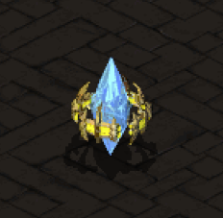

Figure – Sample Object

To model this object accurately, I first had to research what projection the original game used to put the pseudo-3D graphics on to a computer screen. The senior producer of the game, Bill Roper, stated in an interview, “The game play area is an isometric view - not top down like Warcraft. Also, all of the units in StarCraft are fully rendered…” (Roper, 1996).

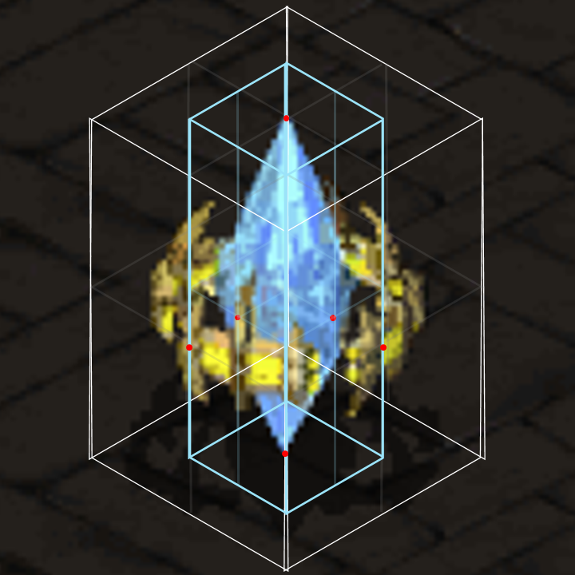I set out to measure the dimensions of a screen capture that I gathered from the game. It was assumed the projection was true isomorphic with an equal 120 degrees between x, y, and z axes. I drew a bounding box around the reference image with that projection, using the SSR30° technique, described in (Kovalenko, 2017), to make an isometric box by applying simple distortions of a square, done using Microsoft Office drawing tools. The bounding box was moved and resized to touch at control points manually identified as the outer radius of the reference sub-objects: the blue crystal and metal outer ring. The box was measured to centimetre on-screen dimensions, but then converted to a ratio to be used to construct the X3D object.

One source of error was that the projection angle in the original game is truthfully a bit shallower than 120 degrees—it appears to be a dimetric projection (Kovalenko, 2017). With close inspection of the squared-off texture on the ground in the reference image compared to the bounding box, it can be seen that the angles do not match. Additionally, a cylinder drawn with the dimensions of the box does not match the object's metal ring. However, measurements at this low pixel resolution were deemed to be precise enough (balanced against the effort required to re-work the diagram in the limited tools utilised).

Figure – Bounding box to measure dimensions

# Techniques Utilised

## Extrusion

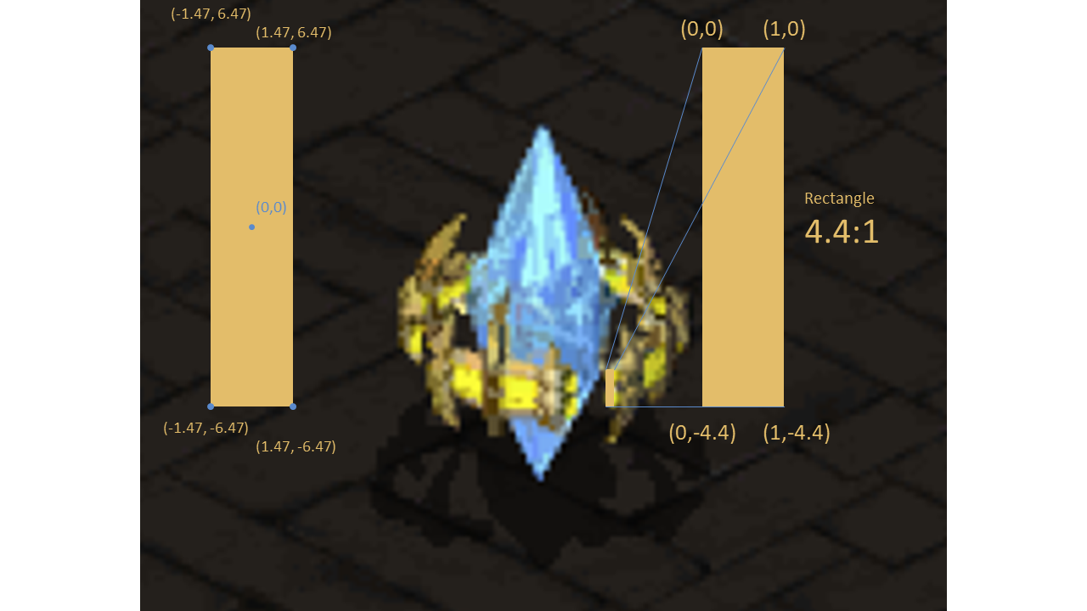The two rings in my model were extruded. While the cross sections were somewhat simple (slightly bevelled boxes), they were also measured to match the pixel dimensions in the game. The arcs to make them into rings was calculated with the parametric formula for a circle, repeated every 1° using an Excel spreadsheet.

The spiked bits attached to those rings were also extruded, with a square/circle combined cross section, two separate curves above and below a straight part of the spine, and a taper to their points.

## Animation & Lighting

The two rings were animated to spin around the central crystal—a detail adapted from the updated StarCraft 2 game. The rate of rotation matches the game asset.

There are several moving light sources that follows a path around the outside of the crystal. These point lights are to give the illusion of an active “science fiction” object. They serve to show off the specular shine on the semi-transparent crystal. The Positional Interpolator they follow is the same path, translated and scaled each time, but their rates between each keyframe is changed alongside the overall cycle time. This ensures the lighting effect is unpredictable.

# GitHub Link

<https://github.com/reideast/GraphicsProject>

# Final Product

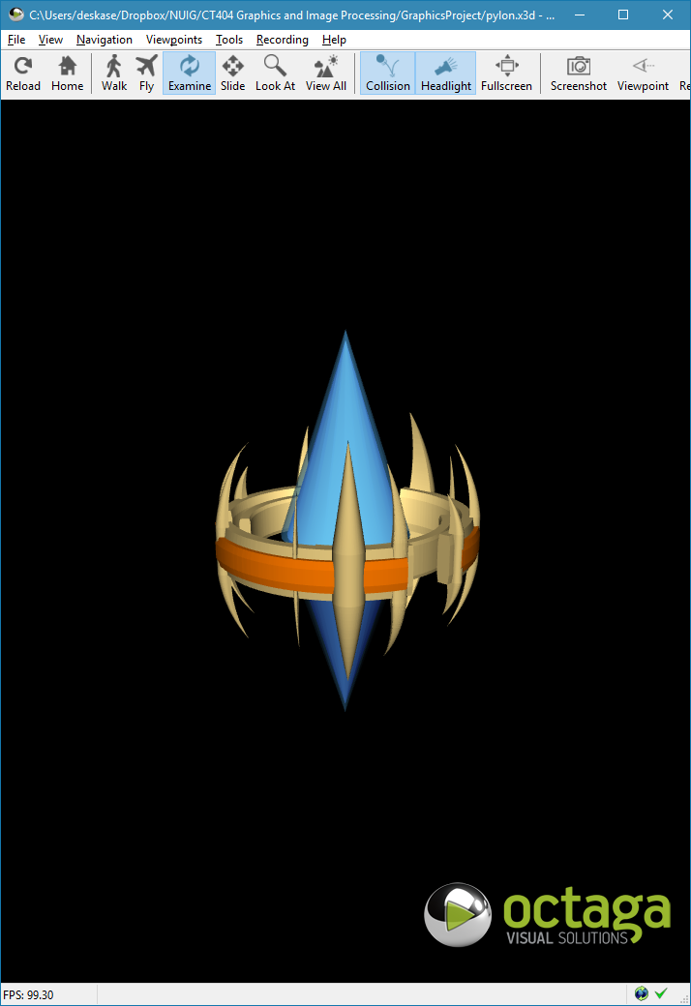

# References

Kovalenko, A. (2017, September 28). *Medium.com.* Retrieved December 1, 2018, from Designer's Guide to Isometric Projection: https://medium.com/gravitdesigner/designers-guide-to-isometric-projection-6bfd66934fc7

Roper, B. (1996, August). Starcraft Producer Bill Roper of Blizzard. (A. Giovetti, Interviewer, & C. G. Wendin, Editor) PC Games. Retrieved November 18, 2018, from http://www.thecomputershow.com/computershow/interviews/starcraftbillroper.htm

Web 3D Consortium. (2013). *Extensible 3D (X3D): Part 1: Architecture and base components Edition 3.* Retrieved November 30, 2018, from http://www.web3d.org/documents/specifications/19775-1/V3.3/Part01/Architecture.html

# Appendix A: Original Plan

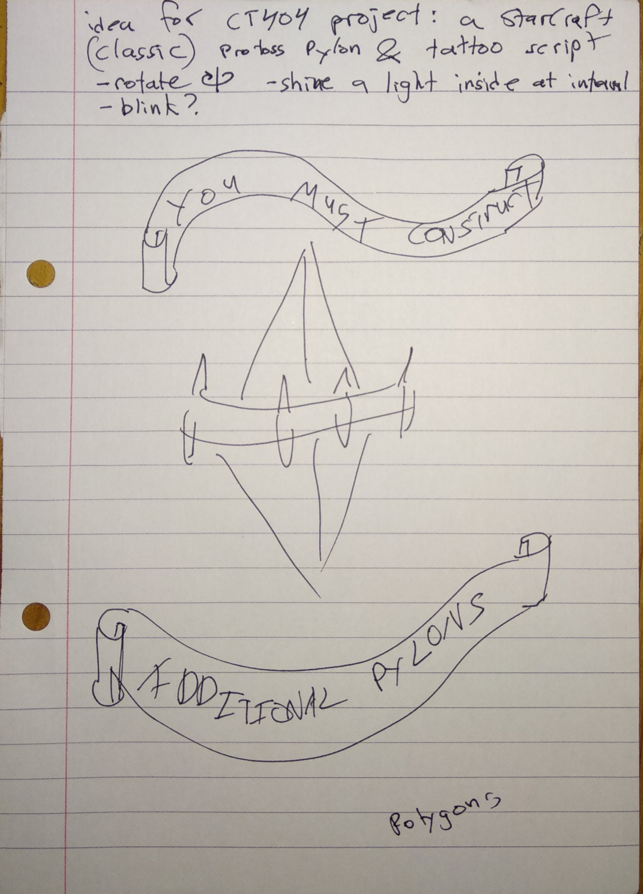

# Appendix B: Code Listing

<?xml version="1.0" encoding="UTF-8"?>

<!DOCTYPE X3D PUBLIC "ISO//Web3D//DTD X3D 3.2//EN" "http://www.web3d.org/specifications/x3d-3.2.dtd">

<X3D profile="Interchange" version="3.2" xmlns:xsd="http://www.w3.org/2001/XMLSchema-instance" xsd:noNamespaceSchemaLocation="http://www.web3d.org/specifications/x3d-3.2.xsd">

<Scene>

<Viewpoint description="Isometric-Style Camera Position" fieldOfView="0.7854" position="0 60 200" orientation="1 0 0 -0.3" />

<PointLight DEF="ambientInnerGlow" location="0 45 0" radius="100" intensity="0.3" />

<Group DEF="ringContainerRoot">

<Transform DEF="ringContainer" scale="0.9 0.9 0.9">

<Transform DEF="ring">

<Group DEF="ringSection"><!-- One third of the ring -->

<Shape DEF="ringSectionShape">

<Appearance DEF="gold">

<Material diffuseColor="0.8588 0.7529 0.4745"/>

</Appearance>

<Extrusion convex="false"

crossSection="-1.47 6.47, 1.47 6.47, 1.87 4, 1.87 -4, 1.47 -6.47, -1.47 -6.47, -1.87 -4, -1.87 4, -1.47 6.47"

spine="5.8 0 -32.88, 5.22 0 -32.98, 4.65 0 -33.07, 4.07 0 -33.14, 3.49 0 -33.21, 2.91 0 -33.26, 2.33 0 -33.31, 1.75 0 -33.34, 1.17 0 -33.37, 0.58 0 -33.38, 0 0 -33.39, -0.58 0 -33.38, -1.17 0 -33.37, -1.75 0 -33.34, -2.33 0 -33.31, -2.91 0 -33.26, -3.49 0 -33.21, -4.07 0 -33.14, -4.65 0 -33.07, -5.22 0 -32.98, -5.8 0 -32.88, -6.37 0 -32.78, -6.94 0 -32.66, -7.51 0 -32.53, -8.08 0 -32.4, -8.64 0 -32.25, -9.2 0 -32.1, -9.76 0 -31.93, -10.32 0 -31.76, -10.87 0 -31.57, -11.42 0 -31.38, -11.97 0 -31.17, -12.51 0 -30.96, -13.05 0 -30.74, -13.58 0 -30.5, -14.11 0 -30.26, -14.64 0 -30.01, -15.16 0 -29.75, -15.68 0 -29.48, -16.19 0 -29.2, -16.7 0 -28.92, -17.2 0 -28.62, -17.69 0 -28.32, -18.19 0 -28, -18.67 0 -27.68, -19.15 0 -27.35, -19.63 0 -27.01, -20.09 0 -26.67, -20.56 0 -26.31, -21.01 0 -25.95, -21.46 0 -25.58, -21.91 0 -25.2, -22.34 0 -24.81, -22.77 0 -24.42, -23.19 0 -24.02, -23.61 0 -23.61, -24.02 0 -23.19, -24.42 0 -22.77, -24.81 0 -22.34, -25.2 0 -21.91, -25.58 0 -21.46, -25.95 0 -21.01, -26.31 0 -20.56, -26.67 0 -20.09, -27.01 0 -19.63, -27.35 0 -19.15, -27.68 0 -18.67, -28 0 -18.19, -28.32 0 -17.69, -28.62 0 -17.2, -28.92 0 -16.7, -29.2 0 -16.19, -29.48 0 -15.68, -29.75 0 -15.16, -30.01 0 -14.64, -30.26 0 -14.11, -30.5 0 -13.58, -30.74 0 -13.05, -30.96 0 -12.51, -31.17 0 -11.97, -31.38 0 -11.42, -31.57 0 -10.87, -31.76 0 -10.32, -31.93 0 -9.76, -32.1 0 -9.2, -32.25 0 -8.64, -32.4 0 -8.08, -32.53 0 -7.51, -32.66 0 -6.94, -32.78 0 -6.37, -32.88 0 -5.8, -32.98 0 -5.22, -33.07 0 -4.65, -33.14 0 -4.07, -33.21 0 -3.49, -33.26 0 -2.91, -33.31 0 -2.33, -33.34 0 -1.75, -33.37 0 -1.17, -33.38 0 -0.58, -33.39 0 0"

/>

</Shape>

</Group>

<Transform rotation="0 1 0 2.094"><!-- 120 degree rotation -->

<Shape USE="ringSection"/>

</Transform>

<Transform rotation="0 1 0 4.188">

<Shape USE="ringSection"/>

</Transform>

<Transform DEF="colouredRing">

<Group DEF="colouredRingSection">

<Shape DEF="colouredRingSectionShape">

<Appearance DEF="teamColour">

<Material diffuseColor="0.9373 0.4471 0.0" />

</Appearance>

<Extrusion convex="false"

crossSection="-1.47 4, 1.47 4, 2 2, 2 -2, 1.47 -4, -1.47 -4, -1.47 4"

spine="3.05 0 -34.87, 2.44 0 -34.91, 1.83 0 -34.95, 1.22 0 -34.98, 0.61 0 -34.99, 0 0 -35, -0.61 0 -34.99, -1.22 0 -34.98, -1.83 0 -34.95, -2.44 0 -34.91, -3.05 0 -34.87, -3.66 0 -34.81, -4.27 0 -34.74, -4.87 0 -34.66, -5.48 0 -34.57, -6.08 0 -34.47, -6.68 0 -34.36, -7.28 0 -34.24, -7.87 0 -34.1, -8.47 0 -33.96, -9.06 0 -33.81, -9.65 0 -33.64, -10.23 0 -33.47, -10.82 0 -33.29, -11.39 0 -33.09, -11.97 0 -32.89, -12.54 0 -32.68, -13.11 0 -32.45, -13.68 0 -32.22, -14.24 0 -31.97, -14.79 0 -31.72, -15.34 0 -31.46, -15.89 0 -31.19, -16.43 0 -30.9, -16.97 0 -30.61, -17.5 0 -30.31, -18.03 0 -30, -18.55 0 -29.68, -19.06 0 -29.35, -19.57 0 -29.02, -20.08 0 -28.67, -20.57 0 -28.32, -21.06 0 -27.95, -21.55 0 -27.58, -22.03 0 -27.2, -22.5 0 -26.81, -22.96 0 -26.41, -23.42 0 -26.01, -23.87 0 -25.6, -24.31 0 -25.18, -24.75 0 -24.75, -25.18 0 -24.31, -25.6 0 -23.87, -26.01 0 -23.42, -26.41 0 -22.96, -26.81 0 -22.5, -27.2 0 -22.03, -27.58 0 -21.55, -27.95 0 -21.06, -28.32 0 -20.57, -28.67 0 -20.08, -29.02 0 -19.57, -29.35 0 -19.06, -29.68 0 -18.55, -30 0 -18.03, -30.31 0 -17.5, -30.61 0 -16.97, -30.9 0 -16.43, -31.19 0 -15.89, -31.46 0 -15.34, -31.72 0 -14.79, -31.97 0 -14.24, -32.22 0 -13.68, -32.45 0 -13.11, -32.68 0 -12.54, -32.89 0 -11.97, -33.09 0 -11.39, -33.29 0 -10.82, -33.47 0 -10.23, -33.64 0 -9.65, -33.81 0 -9.06, -33.96 0 -8.47, -34.1 0 -7.87, -34.24 0 -7.28, -34.36 0 -6.68, -34.47 0 -6.08, -34.57 0 -5.48, -34.66 0 -4.87, -34.74 0 -4.27, -34.81 0 -3.66, -34.87 0 -3.05, -34.91 0 -2.44"

/>

</Shape>

</Group>

<Transform rotation="0 1 0 2.094">

<Shape USE="colouredRingSectionShape"/>

</Transform>

<Transform rotation="0 1 0 4.188">

<Shape USE="colouredRingSectionShape"/>

</Transform>

</Transform>

</Transform>

<Transform DEF="spikeContainer">

<Transform DEF="spikeSpindlyContainer">

<Transform translation="34.39285714 0 0" scale="1 1 1" rotation="0 1 0 3.04" center="-34.39285714 0 0">

<Transform scale="2 1.2 4">

<Shape DEF="spikeSpindly">

<Appearance USE="gold"/>

<Extrusion convex="false"

crossSection="-0.25 0.5, 0.25 0.5, 0.28 0.5, 0.3 0.5, 0.33 0.49, 0.35 0.49, 0.38 0.48, 0.4 0.48, 0.43 0.47, 0.45 0.46, 0.48 0.45, 0.5 0.43, 0.52 0.42, 0.54 0.4, 0.56 0.39, 0.58 0.37, 0.6 0.35, 0.62 0.33, 0.64 0.31, 0.65 0.29, 0.67 0.27, 0.68 0.25, 0.7 0.23, 0.71 0.2, 0.72 0.18, 0.73 0.15, 0.73 0.13, 0.74 0.1, 0.74 0.08, 0.75 0.05, 0.75 0.03, 0.75 0, 0.75 -0.03, 0.75 -0.05, 0.74 -0.08, 0.74 -0.1, 0.73 -0.13, 0.73 -0.15, 0.72 -0.18, 0.71 -0.2, 0.7 -0.23, 0.68 -0.25, 0.67 -0.27, 0.65 -0.29, 0.64 -0.31, 0.62 -0.33, 0.6 -0.35, 0.58 -0.37, 0.56 -0.39, 0.54 -0.4, 0.52 -0.42, 0.5 -0.43, 0.48 -0.45, 0.45 -0.46, 0.43 -0.47, 0.4 -0.48, 0.38 -0.48, 0.35 -0.49, 0.33 -0.49, 0.3 -0.5, 0.28 -0.5, 0.25 -0.5, -0.25 -0.5, -0.25 0.5"

spine="-4.02 21.47 0, -3.76 21.02 0, -3.51 20.56 0, -3.27 20.09 0, -3.04 19.62 0, -2.81 19.15 0, -2.59 18.68 0, -2.38 18.2 0, -2.18 17.71 0, -1.99 17.22 0, -1.81 16.73 0, -1.63 16.24 0, -1.47 15.74 0, -1.31 15.24 0, -1.16 14.74 0, -1.02 14.24 0, -0.89 13.73 0, -0.77 13.22 0, -0.66 12.71 0, -0.55 12.2 0, -0.46 11.68 0, -0.37 11.17 0, -0.29 10.65 0, -0.22 10.13 0, -0.16 9.61 0, -0.11 9.09 0, -0.07 8.57 0, -0.04 8.04 0, -0.02 7.52 0, 0 7 0, 0 6.47 0, 0 -6.47 0, 0 -7 0, -0.02 -7.52 0, -0.04 -8.04 0, -0.07 -8.57 0, -0.11 -9.09 0, -0.16 -9.61 0, -0.22 -10.13 0, -0.29 -10.65 0, -0.37 -11.17 0, -0.46 -11.68 0, -0.55 -12.2 0, -0.66 -12.71 0, -0.77 -13.22 0, -0.89 -13.73 0, -1.02 -14.24 0, -1.16 -14.74 0, -1.31 -15.24 0, -1.47 -15.74 0, -1.63 -16.24 0, -1.81 -16.73 0, -1.99 -17.22 0, -2.18 -17.71 0, -2.38 -18.2 0, -2.59 -18.68 0, -2.81 -19.15 0, -3.04 -19.62 0, -3.27 -20.09 0, -3.51 -20.56 0, -3.76 -21.02 0, -4.02 -21.47 0"

scale="0 0, 0.033333333 0.033333333, 0.066666667 0.066666667, 0.1 0.1, 0.133333333 0.133333333, 0.166666667 0.166666667, 0.2 0.2, 0.233333333 0.233333333, 0.266666667 0.266666667, 0.3 0.3, 0.333333333 0.333333333, 0.366666667 0.366666667, 0.4 0.4, 0.433333333 0.433333333, 0.466666667 0.466666667, 0.5 0.5, 0.533333333 0.533333333, 0.566666667 0.566666667, 0.6 0.6, 0.633333333 0.633333333, 0.666666667 0.666666667, 0.7 0.7, 0.733333333 0.733333333, 0.766666667 0.766666667, 0.8 0.8, 0.833333333 0.833333333, 0.866666667 0.866666667, 0.9 0.9, 0.933333333 0.933333333, 0.966666667 0.966666667, 1 1, 1 1, 0.966666667 0.966666667, 0.933333333 0.933333333, 0.9 0.9, 0.866666667 0.866666667, 0.833333333 0.833333333, 0.8 0.8, 0.766666667 0.766666667, 0.733333333 0.733333333, 0.7 0.7, 0.666666667 0.666666667, 0.633333333 0.633333333, 0.6 0.6, 0.566666667 0.566666667, 0.533333333 0.533333333, 0.5 0.5, 0.466666667 0.466666667, 0.433333333 0.433333333, 0.4 0.4, 0.366666667 0.366666667, 0.333333333 0.333333333, 0.3 0.3, 0.266666667 0.266666667, 0.233333333 0.233333333, 0.2 0.2, 0.166666667 0.166666667, 0.133333333 0.133333333, 0.1 0.1, 0.066666667 0.066666667, 0.033333333 0.033333333, 0 0"

/>

</Shape>

</Transform>

</Transform>

</Transform>

<Transform rotation="0 1 0 2.094"><!-- 120 degrees -->

<Transform USE="spikeSpindlyContainer" />

</Transform>

<Transform DEF="spikeMidContainer">

<Transform translation="34.39285714 0 0" rotation="0 1 0 2.0" center="-34.39285714 0 0">

<Shape DEF="spikeMid">

<Appearance USE="gold"/>

<Extrusion convex="false"

crossSection="-0.5 2, 0.5 2, 0.6 2, 0.71 1.99, 0.81 1.98, 0.92 1.96, 1.02 1.93, 1.12 1.9, 1.22 1.87, 1.31 1.83, 1.41 1.78, 1.5 1.73, 1.59 1.68, 1.68 1.62, 1.76 1.55, 1.84 1.49, 1.91 1.41, 1.99 1.34, 2.05 1.26, 2.12 1.18, 2.18 1.09, 2.23 1, 2.28 0.91, 2.33 0.81, 2.37 0.72, 2.4 0.62, 2.43 0.52, 2.46 0.42, 2.48 0.31, 2.49 0.21, 2.5 0.1, 2.5 0, 2.5 -0.1, 2.49 -0.21, 2.48 -0.31, 2.46 -0.42, 2.43 -0.52, 2.4 -0.62, 2.37 -0.72, 2.33 -0.81, 2.28 -0.91, 2.23 -1, 2.18 -1.09, 2.12 -1.18, 2.05 -1.26, 1.99 -1.34, 1.91 -1.41, 1.84 -1.49, 1.76 -1.55, 1.68 -1.62, 1.59 -1.68, 1.5 -1.73, 1.41 -1.78, 1.31 -1.83, 1.22 -1.87, 1.12 -1.9, 1.02 -1.93, 0.92 -1.96, 0.81 -1.98, 0.71 -1.99, 0.6 -2, 0.5 -2, -0.5 -2, -0.5 2"

spine="-5.36 26.47 0, -5.02 25.87 0, -4.68 25.25 0, -4.36 24.63 0, -4.05 24.01 0, -3.75 23.38 0, -3.46 22.74 0, -3.18 22.1 0, -2.91 21.46 0, -2.66 20.81 0, -2.41 20.15 0, -2.18 19.5 0, -1.96 18.83 0, -1.75 18.17 0, -1.55 17.5 0, -1.36 16.83 0, -1.19 16.15 0, -1.03 15.47 0, -0.87 14.79 0, -0.73 14.11 0, -0.61 13.42 0, -0.49 12.73 0, -0.39 12.04 0, -0.3 11.35 0, -0.22 10.65 0, -0.15 9.96 0, -0.1 9.26 0, -0.05 8.57 0, -0.02 7.87 0, -0.01 7.17 0, 0 6.47 0, 0 -6.47 0, -0.01 -7.17 0, -0.02 -7.87 0, -0.05 -8.57 0, -0.1 -9.26 0, -0.15 -9.96 0, -0.22 -10.65 0, -0.3 -11.35 0, -0.39 -12.04 0, -0.49 -12.73 0, -0.61 -13.42 0, -0.73 -14.11 0, -0.87 -14.79 0, -1.03 -15.47 0, -1.19 -16.15 0, -1.36 -16.83 0, -1.55 -17.5 0, -1.75 -18.17 0, -1.96 -18.83 0, -2.18 -19.5 0, -2.41 -20.15 0, -2.66 -20.81 0, -2.91 -21.46 0, -3.18 -22.1 0, -3.46 -22.74 0, -3.75 -23.38 0, -4.05 -24.01 0, -4.36 -24.63 0, -4.68 -25.25 0, -5.02 -25.87 0, -5.36 -26.47 0"

scale="0 0, 0.033333333 0.033333333, 0.066666667 0.066666667, 0.1 0.1, 0.133333333 0.133333333, 0.166666667 0.166666667, 0.2 0.2, 0.233333333 0.233333333, 0.266666667 0.266666667, 0.3 0.3, 0.333333333 0.333333333, 0.366666667 0.366666667, 0.4 0.4, 0.433333333 0.433333333, 0.466666667 0.466666667, 0.5 0.5, 0.533333333 0.533333333, 0.566666667 0.566666667, 0.6 0.6, 0.633333333 0.633333333, 0.666666667 0.666666667, 0.7 0.7, 0.733333333 0.733333333, 0.766666667 0.766666667, 0.8 0.8, 0.833333333 0.833333333, 0.866666667 0.866666667, 0.9 0.9, 0.933333333 0.933333333, 0.966666667 0.966666667, 1 1, 1 1, 0.966666667 0.966666667, 0.933333333 0.933333333, 0.9 0.9, 0.866666667 0.866666667, 0.833333333 0.833333333, 0.8 0.8, 0.766666667 0.766666667, 0.733333333 0.733333333, 0.7 0.7, 0.666666667 0.666666667, 0.633333333 0.633333333, 0.6 0.6, 0.566666667 0.566666667, 0.533333333 0.533333333, 0.5 0.5, 0.466666667 0.466666667, 0.433333333 0.433333333, 0.4 0.4, 0.366666667 0.366666667, 0.333333333 0.333333333, 0.3 0.3, 0.266666667 0.266666667, 0.233333333 0.233333333, 0.2 0.2, 0.166666667 0.166666667, 0.133333333 0.133333333, 0.1 0.1, 0.066666667 0.066666667, 0.033333333 0.033333333, 0 0"

/>

</Shape>

</Transform>

</Transform>

<Transform rotation="0 1 0 1.60">

<Transform USE="spikeMidContainer" />

</Transform>

<Transform rotation="0 1 0 4.2">

<Transform USE="spikeMidContainer" />

</Transform>

<Transform DEF="spikeBroadContainer">

<Transform translation="34.39285714 0 0" rotation="0 1 0 .87" center="-34.39285714 0 0">

<Shape DEF="spikeBroad">

<Appearance USE="gold"/>

<Extrusion convex="false"

crossSection="-0.5 4, 0.5 4, 0.71 3.99, 0.92 3.98, 1.13 3.95, 1.33 3.91, 1.54 3.86, 1.74 3.8, 1.93 3.73, 2.13 3.65, 2.32 3.56, 2.5 3.46, 2.68 3.35, 2.85 3.24, 3.02 3.11, 3.18 2.97, 3.33 2.83, 3.47 2.68, 3.61 2.52, 3.74 2.35, 3.85 2.18, 3.96 2, 4.06 1.82, 4.15 1.63, 4.23 1.43, 4.3 1.24, 4.36 1.04, 4.41 0.83, 4.45 0.63, 4.48 0.42, 4.49 0.21, 4.5 0, 4.49 -0.21, 4.48 -0.42, 4.45 -0.63, 4.41 -0.83, 4.36 -1.04, 4.3 -1.24, 4.23 -1.43, 4.15 -1.63, 4.06 -1.82, 3.96 -2, 3.85 -2.18, 3.74 -2.35, 3.61 -2.52, 3.47 -2.68, 3.33 -2.83, 3.18 -2.97, 3.02 -3.11, 2.85 -3.24, 2.68 -3.35, 2.5 -3.46, 2.32 -3.56, 2.13 -3.65, 1.93 -3.73, 1.74 -3.8, 1.54 -3.86, 1.33 -3.91, 1.13 -3.95, 0.92 -3.98, 0.71 -3.99, 0.5 -4, -0.5 -4, -0.5 4"

spine="-6.7 31.47 0, -6.27 30.71 0, -5.85 29.95 0, -5.45 29.17 0, -5.06 28.39 0, -4.68 27.6 0, -4.32 26.81 0, -3.97 26.01 0, -3.64 25.2 0, -3.32 24.39 0, -3.02 23.57 0, -2.72 22.75 0, -2.45 21.92 0, -2.18 21.09 0, -1.94 20.26 0, -1.7 19.41 0, -1.49 18.57 0, -1.28 17.72 0, -1.09 16.87 0, -0.92 16.01 0, -0.76 15.16 0, -0.62 14.29 0, -0.49 13.43 0, -0.37 12.57 0, -0.27 11.7 0, -0.19 10.83 0, -0.12 9.96 0, -0.07 9.09 0, -0.03 8.22 0, -0.01 7.35 0, 0 6.47 0, 0 -6.47 0, -0.01 -7.35 0, -0.03 -8.22 0, -0.07 -9.09 0, -0.12 -9.96 0, -0.19 -10.83 0, -0.27 -11.7 0, -0.37 -12.57 0, -0.49 -13.43 0, -0.62 -14.29 0, -0.76 -15.16 0, -0.92 -16.01 0, -1.09 -16.87 0, -1.28 -17.72 0, -1.49 -18.57 0, -1.7 -19.41 0, -1.94 -20.26 0, -2.18 -21.09 0, -2.45 -21.92 0, -2.72 -22.75 0, -3.02 -23.57 0, -3.32 -24.39 0, -3.64 -25.2 0, -3.97 -26.01 0, -4.32 -26.81 0, -4.68 -27.6 0, -5.06 -28.39 0, -5.45 -29.17 0, -5.85 -29.95 0, -6.27 -30.71 0, -6.7 -31.47 0"

scale="0 0, 0.033333333 0.033333333, 0.066666667 0.066666667, 0.1 0.1, 0.133333333 0.133333333, 0.166666667 0.166666667, 0.2 0.2, 0.233333333 0.233333333, 0.266666667 0.266666667, 0.3 0.3, 0.333333333 0.333333333, 0.366666667 0.366666667, 0.4 0.4, 0.433333333 0.433333333, 0.466666667 0.466666667, 0.5 0.5, 0.533333333 0.533333333, 0.566666667 0.566666667, 0.6 0.6, 0.633333333 0.633333333, 0.666666667 0.666666667, 0.7 0.7, 0.733333333 0.733333333, 0.766666667 0.766666667, 0.8 0.8, 0.833333333 0.833333333, 0.866666667 0.866666667, 0.9 0.9, 0.933333333 0.933333333, 0.966666667 0.966666667, 1 1, 1 1, 0.966666667 0.966666667, 0.933333333 0.933333333, 0.9 0.9, 0.866666667 0.866666667, 0.833333333 0.833333333, 0.8 0.8, 0.766666667 0.766666667, 0.733333333 0.733333333, 0.7 0.7, 0.666666667 0.666666667, 0.633333333 0.633333333, 0.6 0.6, 0.566666667 0.566666667, 0.533333333 0.533333333, 0.5 0.5, 0.466666667 0.466666667, 0.433333333 0.433333333, 0.4 0.4, 0.366666667 0.366666667, 0.333333333 0.333333333, 0.3 0.3, 0.266666667 0.266666667, 0.233333333 0.233333333, 0.2 0.2, 0.166666667 0.166666667, 0.133333333 0.133333333, 0.1 0.1, 0.066666667 0.066666667, 0.033333333 0.033333333, 0 0"

/>

</Shape>

</Transform>

</Transform>

<Transform rotation="0 1 0 3.9">

<Transform USE="spikeBroadContainer" />

</Transform>

<Transform DEF="spikeSquatContainer">

<Transform translation="34.39285714 0 0" rotation="0 1 0 -0.6" center="-34.39285714 0 0">

<Shape DEF="spikeSquat">

<Appearance USE="gold"/>

<Extrusion convex="false"

crossSection="-1 1.5, 1 1.5, 1.08 1.5, 1.16 1.49, 1.23 1.48, 1.31 1.47, 1.39 1.45, 1.46 1.43, 1.54 1.4, 1.61 1.37, 1.68 1.34, 1.75 1.3, 1.82 1.26, 1.88 1.21, 1.94 1.17, 2 1.11, 2.06 1.06, 2.11 1, 2.17 0.94, 2.21 0.88, 2.26 0.82, 2.3 0.75, 2.34 0.68, 2.37 0.61, 2.4 0.54, 2.43 0.46, 2.45 0.39, 2.47 0.31, 2.48 0.23, 2.49 0.16, 2.5 0.08, 2.5 0, 2.5 -0.08, 2.49 -0.16, 2.48 -0.23, 2.47 -0.31, 2.45 -0.39, 2.43 -0.46, 2.4 -0.54, 2.37 -0.61, 2.34 -0.68, 2.3 -0.75, 2.26 -0.82, 2.21 -0.88, 2.17 -0.94, 2.11 -1, 2.06 -1.06, 2 -1.11, 1.94 -1.17, 1.88 -1.21, 1.82 -1.26, 1.75 -1.3, 1.68 -1.34, 1.61 -1.37, 1.54 -1.4, 1.46 -1.43, 1.39 -1.45, 1.31 -1.47, 1.23 -1.48, 1.16 -1.49, 1.08 -1.5, 1 -1.5, -1 -1.5, -1 1.5"

spine="-2.68 16.47 0, -2.51 16.17 0, -2.34 15.86 0, -2.18 15.55 0, -2.02 15.24 0, -1.87 14.93 0, -1.73 14.61 0, -1.59 14.29 0, -1.46 13.97 0, -1.33 13.64 0, -1.21 13.31 0, -1.09 12.98 0, -0.98 12.65 0, -0.87 12.32 0, -0.77 11.99 0, -0.68 11.65 0, -0.59 11.31 0, -0.51 10.97 0, -0.44 10.63 0, -0.37 10.29 0, -0.3 9.95 0, -0.25 9.6 0, -0.19 9.26 0, -0.15 8.91 0, -0.11 8.56 0, -0.08 8.22 0, -0.05 7.87 0, -0.03 7.52 0, -0.01 7.17 0, 0 6.82 0, 0 6.47 0, 0 -6.47 0, 0 -6.82 0, -0.01 -7.17 0, -0.03 -7.52 0, -0.05 -7.87 0, -0.08 -8.22 0, -0.11 -8.56 0, -0.15 -8.91 0, -0.19 -9.26 0, -0.25 -9.6 0, -0.3 -9.95 0, -0.37 -10.29 0, -0.44 -10.63 0, -0.51 -10.97 0, -0.59 -11.31 0, -0.68 -11.65 0, -0.77 -11.99 0, -0.87 -12.32 0, -0.98 -12.65 0, -1.09 -12.98 0, -1.21 -13.31 0, -1.33 -13.64 0, -1.46 -13.97 0, -1.59 -14.29 0, -1.73 -14.61 0, -1.87 -14.93 0, -2.02 -15.24 0, -2.18 -15.55 0, -2.34 -15.86 0, -2.51 -16.17 0, -2.68 -16.47 0"

scale="0 0, 0.033333333 0.033333333, 0.066666667 0.066666667, 0.1 0.1, 0.133333333 0.133333333, 0.166666667 0.166666667, 0.2 0.2, 0.233333333 0.233333333, 0.266666667 0.266666667, 0.3 0.3, 0.333333333 0.333333333, 0.366666667 0.366666667, 0.4 0.4, 0.433333333 0.433333333, 0.466666667 0.466666667, 0.5 0.5, 0.533333333 0.533333333, 0.566666667 0.566666667, 0.6 0.6, 0.633333333 0.633333333, 0.666666667 0.666666667, 0.7 0.7, 0.733333333 0.733333333, 0.766666667 0.766666667, 0.8 0.8, 0.833333333 0.833333333, 0.866666667 0.866666667, 0.9 0.9, 0.933333333 0.933333333, 0.966666667 0.966666667, 1 1, 1 1, 0.966666667 0.966666667, 0.933333333 0.933333333, 0.9 0.9, 0.866666667 0.866666667, 0.833333333 0.833333333, 0.8 0.8, 0.766666667 0.766666667, 0.733333333 0.733333333, 0.7 0.7, 0.666666667 0.666666667, 0.633333333 0.633333333, 0.6 0.6, 0.566666667 0.566666667, 0.533333333 0.533333333, 0.5 0.5, 0.466666667 0.466666667, 0.433333333 0.433333333, 0.4 0.4, 0.366666667 0.366666667, 0.333333333 0.333333333, 0.3 0.3, 0.266666667 0.266666667, 0.233333333 0.233333333, 0.2 0.2, 0.166666667 0.166666667, 0.133333333 0.133333333, 0.1 0.1, 0.066666667 0.066666667, 0.033333333 0.033333333, 0 0"

/>

</Shape>

</Transform>

</Transform>

<Transform rotation="0 1 0 2.094"><!-- 120 degrees -->

<Transform USE="spikeSquatContainer" />

</Transform>

<Transform rotation="0 1 0 3.3">

<Transform USE="spikeSquatContainer" />

</Transform>

<Transform DEF="spikeSkinnyContainer">

<Transform translation="34.99285714 0 0" rotation="0 1 0 0.5" center="-34.99285714 0 0">

<Shape DEF="spikeSkinny">

<Appearance USE="gold"/>

<Extrusion convex="false"

crossSection="-0.5 0.5, 0.5 0.5, 0.53 0.5, 0.55 0.5, 0.58 0.49, 0.6 0.49, 0.63 0.48, 0.65 0.48, 0.68 0.47, 0.7 0.46, 0.73 0.45, 0.75 0.43, 0.77 0.42, 0.79 0.4, 0.81 0.39, 0.83 0.37, 0.85 0.35, 0.87 0.33, 0.89 0.31, 0.9 0.29, 0.92 0.27, 0.93 0.25, 0.95 0.23, 0.96 0.2, 0.97 0.18, 0.98 0.15, 0.98 0.13, 0.99 0.1, 0.99 0.08, 1 0.05, 1 0.03, 1 0, 1 -0.03, 1 -0.05, 0.99 -0.08, 0.99 -0.1, 0.98 -0.13, 0.98 -0.15, 0.97 -0.18, 0.96 -0.2, 0.95 -0.23, 0.93 -0.25, 0.92 -0.27, 0.9 -0.29, 0.89 -0.31, 0.87 -0.33, 0.85 -0.35, 0.83 -0.37, 0.81 -0.39, 0.79 -0.4, 0.77 -0.42, 0.75 -0.43, 0.73 -0.45, 0.7 -0.46, 0.68 -0.47, 0.65 -0.48, 0.63 -0.48, 0.6 -0.49, 0.58 -0.49, 0.55 -0.5, 0.53 -0.5, 0.5 -0.5, -0.5 -0.5, -0.5 0.5"

spine="-1.22 20.37 0, -0.98 18.99 0, -0.78 17.61 0, -0.6 16.22 0, -0.44 14.84 0, -0.3 13.45 0, -0.19 12.05 0, -0.11 10.66 0, -0.05 9.27 0, -0.01 7.87 0, 0 6.47 0, 0 -6.47 0, -0.01 -7.87 0, -0.05 -9.27 0, -0.11 -10.66 0, -0.19 -12.05 0, -0.3 -13.45 0, -0.44 -14.84 0, -0.6 -16.22 0, -0.78 -17.61 0, -0.98 -18.99 0, -1.22 -20.37 0"

scale="0 0, 0.1 0.1, 0.2 0.2, 0.3 0.3, 0.4 0.4, 0.5 0.5, 0.6 0.6, 0.7 0.7, 0.8 0.8, 0.9 0.9, 1 1, 1 1, 0.9 0.9, 0.8 0.8, 0.7 0.7, 0.6 0.6, 0.5 0.5, 0.4 0.4, 0.3 0.3, 0.2 0.2, 0.1 0.1, 0 0"

/>

</Shape>

</Transform>

</Transform>

<Transform rotation="0 1 0 3.9">

<Transform USE="spikeSkinnyContainer" />

</Transform>

</Transform>

</Transform>

<!-- Animation of Ring -->

<TimeSensor DEF="intervalRotateRing" loop="true" cycleInterval="12.0"/><!-- rotate at 1/10 rps forever -->

<OrientationInterpolator DEF="animateRotateRing" key="0 0.5 1" keyValue="0 1 0 0, 0 1 0 3.14, 0 1 0 6.28"/>

<ROUTE fromNode="intervalRotateRing" fromField="fraction_changed" toNode="animateRotateRing" toField="set_fraction"/>

<ROUTE fromNode="animateRotateRing" fromField="value_changed" toNode="ringContainer" toField="set_rotation"/>

</Group>

<Group DEF="innerRingContainerRoot">

<Transform DEF="innerRingContainer" scale="0.9 0.9 0.9">

<Transform DEF="innerRing">

<Group DEF="innerRingSection"><!-- One half of the inner ring -->

<Shape DEF="innerRingSectionShape">

<Appearance USE="gold" />

<Extrusion convex="false"

crossSection="-1.47 5, 1 5, 1.3 4, 1.3 -4, 1 -5, -1.47 -5, -1.77 -4, -1.77 4, -1.47 5"

spine="28 0 0, 28 0 -0.49, 27.98 0 -0.98, 27.96 0 -1.47, 27.93 0 -1.95, 27.89 0 -2.44, 27.85 0 -2.93, 27.79 0 -3.41, 27.73 0 -3.9, 27.66 0 -4.38, 27.57 0 -4.86, 27.49 0 -5.34, 27.39 0 -5.82, 27.28 0 -6.3, 27.17 0 -6.77, 27.05 0 -7.25, 26.92 0 -7.72, 26.78 0 -8.19, 26.63 0 -8.65, 26.47 0 -9.12, 26.31 0 -9.58, 26.14 0 -10.03, 25.96 0 -10.49, 25.77 0 -10.94, 25.58 0 -11.39, 25.38 0 -11.83, 25.17 0 -12.27, 24.95 0 -12.71, 24.72 0 -13.15, 24.49 0 -13.57, 24.25 0 -14, 24 0 -14.42, 23.75 0 -14.84, 23.48 0 -15.25, 23.21 0 -15.66, 22.94 0 -16.06, 22.65 0 -16.46, 22.36 0 -16.85, 22.06 0 -17.24, 21.76 0 -17.62, 21.45 0 -18, 21.13 0 -18.37, 20.81 0 -18.74, 20.48 0 -19.1, 20.14 0 -19.45, 19.8 0 -19.8, 19.45 0 -20.14, 19.1 0 -20.48, 18.74 0 -20.81, 18.37 0 -21.13, 18 0 -21.45, 17.62 0 -21.76, 17.24 0 -22.06, 16.85 0 -22.36, 16.46 0 -22.65, 16.06 0 -22.94, 15.66 0 -23.21, 15.25 0 -23.48, 14.84 0 -23.75, 14.42 0 -24, 14 0 -24.25, 13.57 0 -24.49, 13.15 0 -24.72, 12.71 0 -24.95, 12.27 0 -25.17, 11.83 0 -25.38, 11.39 0 -25.58, 10.94 0 -25.77, 10.49 0 -25.96, 10.03 0 -26.14, 9.58 0 -26.31, 9.12 0 -26.47, 8.65 0 -26.63, 8.19 0 -26.78, 7.72 0 -26.92, 7.25 0 -27.05, 6.77 0 -27.17, 6.3 0 -27.28, 5.82 0 -27.39, 5.34 0 -27.49, 4.86 0 -27.57, 4.38 0 -27.66, 3.9 0 -27.73, 3.41 0 -27.79, 2.93 0 -27.85, 2.44 0 -27.89, 1.95 0 -27.93, 1.47 0 -27.96, 0.98 0 -27.98, 0.49 0 -28, 0 0 -28, -0.49 0 -28, -0.98 0 -27.98, -1.47 0 -27.96, -1.95 0 -27.93, -2.44 0 -27.89, -2.93 0 -27.85, -3.41 0 -27.79, -3.9 0 -27.73, -4.38 0 -27.66, -4.86 0 -27.57, -5.34 0 -27.49, -5.82 0 -27.39, -6.3 0 -27.28, -6.77 0 -27.17, -7.25 0 -27.05, -7.72 0 -26.92, -8.19 0 -26.78, -8.65 0 -26.63, -9.12 0 -26.47, -9.58 0 -26.31"

/>

</Shape>

</Group>

<Transform rotation="0 1 0 3.141"><!-- 180 degree rotation -->

<Shape USE="innerRingSection"/>

</Transform>

</Transform>

</Transform>

<!-- Animation of Inner Ring -->

<TimeSensor DEF="intervalRotateInnerRing" loop="true" cycleInterval="10.0"/>

<OrientationInterpolator DEF="animateRotateInnerRing" key="0 0.5 1" keyValue="0 1 0 6.28, 0 1 0 3.14, 0 1 0 0"/>

<ROUTE fromNode="intervalRotateInnerRing" fromField="fraction_changed" toNode="animateRotateInnerRing" toField="set_fraction"/>

<ROUTE fromNode="animateRotateInnerRing" fromField="value_changed" toNode="innerRingContainer" toField="set_rotation"/>

</Group>

<Group DEF="crystalContainerRoot">

<Transform DEF="crystalContainer">

<Transform DEF="glowingInnerCrystal" translation="0 23.75 0">

<Shape DEF="crystalHalf">

<Appearance DEF="crystalColour">

<Material

diffuseColor="0.5961 0.9843 1.0"

emissiveColor="0 0 0.5"

specularColor="0.7216 1.0 1.0"

shininess="1.0"

/>

</Appearance>

<Cone height="47.5" bottomRadius="14.70" side="true" bottom="false"/>

</Shape>

<Transform rotation="0 0 1 3.14" center="0 -23.75 0">

<Shape USE="crystalHalf"/>

</Transform>

</Transform>

<!-- Animate a small point light around the crystal to give it an animated glow -->

<Transform>

<PointLight DEF="glowInsideCrystal" location="8 20 0" intensity="1.0" attenuation="0 0.1 0.009"/>

<TimeSensor DEF="intervalMoveGlowInsideCrystal" loop="true" cycleInterval="8"/>

<PositionInterpolator DEF="moveGlowInsideCrystal" key="0 0.2 0.6 0.75 1"

keyValue="15 0 15, 7 30 7, -1 35 8, 1 30 10, 15 0 15"/><!-- Key will "swoop" then "nudge" then "steadily move back to start" -->

<ROUTE fromNode="intervalMoveGlowInsideCrystal" fromField="fraction_changed" toNode="moveGlowInsideCrystal" toField="set_fraction"/>

<ROUTE fromNode="moveGlowInsideCrystal" fromField="value_changed" toNode="glowInsideCrystal" toField="set_location"/>

</Transform>

<!-- Animate a second point light around the crystal to give it an animated glow -->

<Transform rotation="0 1 0 2.3561">

<PointLight DEF="glowInsideCrystal2" location="8 20 0" intensity="1.0" attenuation="0 0.1 0.009"/>

<TimeSensor DEF="intervalMoveGlowInsideCrystal2" loop="true" cycleInterval="4"/>

<PositionInterpolator DEF="moveGlowInsideCrystal2" key="0 0.1 0.3 0.6 1"

keyValue="15 0 15, 7 30 7, -1 35 8, 1 30 10, 15 0 15"/><!-- Key will "swoop" then "nudge" then "steadily move back to start" -->

<ROUTE fromNode="intervalMoveGlowInsideCrystal2" fromField="fraction_changed" toNode="moveGlowInsideCrystal2" toField="set_fraction"/>

<ROUTE fromNode="moveGlowInsideCrystal2" fromField="value_changed" toNode="glowInsideCrystal2" toField="set_location"/>

</Transform>

<!-- Animate a second point light around the crystal to give it an animated glow -->

<Transform translation="0 -40 0">

<Transform rotation="0 1 0 3.141">

<PointLight DEF="glowInsideCrystal3" location="8 20 0" intensity="1.0" attenuation="0 0.1 0.009"/>

<TimeSensor DEF="intervalMoveGlowInsideCrystal3" loop="true" cycleInterval="6"/>

<PositionInterpolator DEF="moveGlowInsideCrystal3" key="0 0.1 0.3 0.6 1"

keyValue="15 0 15, 7 30 7, -1 35 8, 1 30 10, 15 0 15"/><!-- Key will "swoop" then "nudge" then "steadily move back to start" -->

<ROUTE fromNode="intervalMoveGlowInsideCrystal3" fromField="fraction_changed" toNode="moveGlowInsideCrystal3" toField="set_fraction"/>

<ROUTE fromNode="moveGlowInsideCrystal3" fromField="value_changed" toNode="glowInsideCrystal3" toField="set_location"/>

</Transform>

</Transform>

<Transform DEF="outerCrystal" translation="0 25 0">

<Shape DEF="outerCrystalHalf">

<Appearance>

<Material

diffuseColor="0.3098 0.6549 0.8941"

transparency="0.3"

/>

</Appearance>

<Cone height="50" bottomRadius="16.3" side="true" bottom="false"/>

</Shape>

<Transform rotation="0 0 1 3.14" center="0 -25 0">

<Shape USE="outerCrystalHalf"/>

</Transform>

</Transform>

</Transform>

<!-- Animation of Crystal -->

<TimeSensor DEF="intervalRotateCrystal" loop="true" cycleInterval="12.0" /><!-- rotate at 1/12 rps forever -->

<OrientationInterpolator DEF="animateRotateCrystal" key="0 0.5 1" keyValue="0 1 0 0, 0 1 0 3.14, 0 1 0 6.28"/>

<ROUTE fromNode="intervalRotateCrystal" fromField="fraction_changed" toNode="animateRotateCrystal" toField="set_fraction" />

<ROUTE fromNode="animateRotateCrystal" fromField="value_changed" toNode="crystalContainer" toField="set_rotation" />

</Group>

</Scene>

</X3D>